Episodic river flow drives microplastic transport to Monterey Bay, California

Matthew S. Savoca^{1,2}, Pam Krone¹, Rebecca Roberts¹, Angela Anguiano³, Hazel Vaquero³, Scott Coffin⁴, Win Cowger³

Affiliations
¹California Marine Sanctuary Foundation, Monterey, CA, USA
²Hopkins Marine Station, Stanford University, Pacific Grove, CA, USA
³Moore Institute for Plastic Pollution Research, Long Beach, CA, USA
⁴California Office of Environmental Health Hazard Assessment, Sacramento, CA, USA

Abstract
Intermittent rivers may deliver microplastics to coastal oceans in concentrated pulses, yet their contribution to land-sea plastic transport remains poorly resolved, particularly for smaller particles. From 2023 to 2025, we sampled the four major rivers that empty into Monterey Bay – a large open-ocean bay on the U.S. west coast – collecting samples before, during, and after periods of heavy winter and spring rainfall. In a total of 11,400 L of river water, we identified 3,777 microplastics in the 50-500 µm fraction using μFTIR, while an additional 237 putative microplastics were visually identified in the 500-5000 µm size fraction. Average concentration in the 50-500 µm fraction was 0.33 microplastics L⁻¹ and varied substantially through time but did not differ significantly among rivers, sampling seasons, or depths. While μFTIR analysis confirmed 23 different polymer types, over 84% were polypropylene (34.3%), polyamides (29.2%), polyethylene (12.1%), and polystyrene (8.8%). The first major storm of the 2023-2024 wet season transported an estimated ~10 billion 50-500 µm microplastics from the four rivers to coastal waters (25th–75th percentile concentration scenarios: 6.2–32.1 billion). Microplastic abundance increased steeply with decreasing size, and power-law size-distribution modeling yielded a model-based concentration of a median of approximately 110 particles L⁻¹ (river-specific power-law slopes; 190 particles L⁻¹ under a two-segment size distribution) across the full 1-5000 µm microplastic size range. Together, these results identify episodic discharge and analytical size range as major controls on estimates of riverine microplastic delivery and suggest that conventional measurements capture only a small fraction of microplastics that may affect downstream coastal ecosystems.

Key words: Plastic pollution, microplastic, microfiber, flood, hydrology, land-to-sea transport, particle size distribution

Synopsis:
Storm-driven river discharge is a key control on microplastic flux to coastal waters, while abundant unresolved smaller particles may substantially increase the magnitude and biological impacts of these inputs.

Introduction
Plastic pollution is a defining environmental challenge of the Anthropocene, with microplastics (< 5 mm) now detected in every major habitat on Earth, from alpine snowfields to deep-sea sediments¹. Despite this, the dominant pathways and processes governing the transport of plastics from land to the ocean remain poorly understood. Most plastics are neutrally or positively buoyant, enabling prolonged suspension in aquatic environments, exacerbating risks to aquatic wildlife and increasing the likelihood to be carried to distant waters and disparate ecosystems². Rivers are a key pathway by which plastic pollution of all sizes reach the ocean^{3–6}; however, microplastic concentrations – which ultimately influence their biological effects – in rivers vary by several orders of magnitude; some of this variability is inherent and some is the result of sample collection, processing, and analysis⁷. Resolving microplastic concentrations in rivers and their timing and flux to the sea is vital to understanding the threat of this contaminant to coastal communities and ecosystems.
Global estimates of plastic transport from land to the ocean have changed considerably over the past decade. Early global models suggested that rivers transfer approximately 2-4 Mt of plastic to the ocean annually^{3,4}. These estimates are now thought to be biased high due to limited observations and simplifying assumptions. More recent efforts that incorporate improved waste management data, hydrology, and river networks estimate global riverine plastic emissions of approximately 0.5 Mt per year⁵. In parallel, the spatial attribution of riverine plastic emissions has shifted from a paradigm dominated by a small number of large rivers to one in which plastic export is far more diffuse. Initially, only two dozen major rivers were considered dominant contributors³, but updated analyses have found that more than 1,000 rivers worldwide may each contribute meaningfully to global plastic emissions⁸.
While initial estimates tended to focus on macroplastics^{3,9,10}, the past five years, have seen rapid growth in studies quantifying microplastic concentrations and fluxes in rivers. These studies reveal that river microplastic transport is strongly mediated by hydrology, varying dramatically over time in response to discharge, seasonality, and storm events^{11–14}. However, the strongest determinant of microplastic concentrations is often human population density^{15–17}. Importantly, river systems differ widely in flow regimes: some rivers are perennial, others ephemeral, and many – particularly in Mediterranean-climate regions – are intermittent, flowing seasonally or episodically in response to heavy precipitation. These hydrologic differences influence when, how, and in what quantities microplastics are mobilized and exported to downstream environments^{11,14,18,19}.
An additional source of variability in reported microplastic concentrations is the particle-size range captured by different sampling and analytical approaches. Environmental microplastic abundance generally increases nonlinearly with decreasing particle size, such that measurements using coarse meshes can exclude a numerically dominant fraction of smaller particles^{20–25}. Particle-size distributions (PSDs) can be described using power-law relationships, providing a framework for aligning measurements made across different size ranges and estimating abundance below directly observed particles. However, such extrapolations depend strongly on the fitted PSD and require explicit consideration of uncertainty in extending the relationships of observed microplastics toward smaller particles²⁵. Resolving both hydrologic variability and particle-size distributions is therefore necessary to constrain riverine microplastic abundance and transport.
The four major rivers discharging into Monterey Bay, and the adjacent Carmel Bay, are the San Lorenzo, Pajaro, Salinas, and Carmel Rivers from north to south (Fig. 1A). Together, these rivers drain watersheds that span a wide range of land uses and population densities, including urban development in the San Lorenzo River watershed (Santa Cruz, California), intensive agricultural landscapes in the Pajaro and Salinas River watersheds, and a smaller, affluent suburban catchment associated with the Carmel River. Despite these contrasting watershed characteristics and their direct connection to a biologically productive coastal ocean, plastic pollution in these rivers has not been previously quantified. All four systems share a strongly seasonal, intermittent hydrology, with minimal or no flow for much of the year punctuated by episodic winter and spring storm events that dominate annual discharge. The prolonged low-flow conditions may promote the accumulation of plastics within river channels, sediment, and stagnant sections. Subsequent high-discharge events may rapidly mobilize microplastics that have accumulated within river channels, sediments, and low-flow reaches to the coastal ocean. Similar pulse-driven microplastic transport has been documented in other river systems^{11,13,14,18,19}.
Plastic pollution in the four rivers in our study have not previously been measured, and the magnitude, timing, and polymer composition of riverine microplastic inputs to the region is unknown despite their recurrent connection to a highly productive coastal ecosystem. In contrast, microplastics have been repeatedly documented throughout Monterey Bay, in seawater from the surface to depths of 1,000 m^{26,27}, across trophic levels from the bathy- to epipelagic^{26,28,29}, and in commercially harvested species²⁹. Together, these river-open bay systems form a coupled terrestrial-marine observatory that enables microplastics to be used as tracers of watershed processes, hydrologic variability, and the timing and magnitude of downstream exposure and risk to coastal ecosystems.
Assessing potential exposure of aquatic organisms to riverine microplastics requires resolving not only when particles are transported, but also their concentrations, size distributions, polymer composition, and behavior under realistic hydrologic conditions. Yet few studies have repeatedly quantified particle-resolved microplastic concentrations across multiple size classes in intermittent rivers. By leveraging the intermittent hydrology and contrasting watershed characteristics of rivers discharging into Monterey Bay, we quantify microplastic concentrations, particle-size and shape distributions, polymer composition, and flux as a function of river discharge. We additionally evaluate whether polymer density is associated with vertical particle sorting between surface and subsurface waters. Finally, we use empirically fitted power-law particle-size distributions to place our directly measured concentrations within the full 1-5000 µm microplastic size range and evaluate the sensitivity of these extrapolations to alternative particle-size-distribution structures. Together, these analyses link hydrologic transport with particle-scale properties to constrain both the timing and magnitude of microplastic delivery from intermittent rivers to the coastal ocean.

Materials and Methods
Field sites
River samples were collected at four major Central Coast systems – the Salinas, Pajaro, San Lorenzo, and Carmel Rivers (Fig. 1) – representing mixed agricultural and urbanized watersheds. Specifically, the Salinas and Pajaro sites are classified as agricultural watersheds and the Carmel and San Lorenzo sites are considered urban. All sampling sites were bridges over the river, within 3 km of where the river discharged into Monterey Bay (Fig. 1). This was done to sample the thalweg of the river to avoid bank effects and obtain samples that were most representative of what was being transported downriver. In the first season, we sampled each river’s stagnant lower reaches before the first storm events. Additional sampling was conducted as near to a storm event as possible to capture near peak flow, except for the final monitoring events in 2025 (Fig. 2). Because the end of the wet season was approaching, sampling needed to occur prior to the subsidence of river discharge. All sampling took place from December to May, which is the season when the region receives > 90% of its annual precipitation.

Microplastic collection methods
At each site, surface and subsurface water samples were obtained using a Teledyne ISCO peristaltic pump connected to two, stacked stainless-steel sieves (500 µm and 54 µm mesh). Each ISCO unit pumped approximately 200 L of water per sample at 4 L min⁻¹ over a 50-minute period. Field blanks (one per river per year) were collected simultaneously by exposing a secondary sieve stack to ambient air and rinsing with deionized water to capture potential airborne contamination. Samples were preserved with 10 mL of 70% isopropyl alcohol and stored in airtight glass containers for up to a year until processing.

Laboratory Methods
For the larger size class of microplastics in our study (500-5000 µm), samples underwent visual isolation under a Nikon SMZ745 stereomicroscope (3-300x). Suspected plastics were transferred to glass slides with double sided sticky tape and classified by morphology as in ref.³⁰. Color, morphology, and approximate size (within 100 µm) were recorded for each putative microplastic.
The Moore Institute for Plastic Pollution Research is a California Environmental Laboratory Accreditation Program (ELAP)-accredited lab for microplastic analysis in drinking water (SWB-MP1-Rev1) and conducted the analytical chemistry and filtration analysis for this study as dictated by their standard approach but added new methods for prior extraction due to the abundance of particles in river water compared to drinking water. Samples underwent size separation and were sieved using 20 μm sieves. For microplastics (> 20 µm), samples were digested using 20% KOH and density separated using filtered (< 1 μm glass fiber filter) seawater collected at Belmont Pier, Long Beach, CA. The decanted density fluid was filtered onto one or more 25 mm stainless steel filters with a 5 μm pore size for FTIR analysis. Filters were processed on a Thermo Scientific Nicolet™ iN™10 MX FTIR microscope in reflectance mode with an 8X2 MCT array detector (4000-675 cm⁻¹, 16 cm⁻¹ resolution, 25 um step size).
As laboratory procedures were refined, the amount of sample analyzed by FTIR was standardized. Initially, the entire sample was analyzed, which led to multiday runs per sample and was not feasible within the study's budget and likely unnecessary given only 100 microplastic particles are needed for standard statistical confidence of < 10% error³¹ and each filter analyzed 1000s of particles. Later, analysis was limited to a maximum of three aliquots (subsamples) per sample, and the aliquot-to-sample volume ratio was recorded to extrapolate particle counts to the entire sample. Quality control included procedural blanks, field blanks, and duplicate subsampling to quantify contamination and analytical uncertainty. Positive controls and recovery rates were assessed using standardized lab spikes. One spike, one procedural blank, and one air blank were run per 20 samples. Spikes consisted of polyethylene, polyolefins, cellulose acetate, and PVC dust reference material. Blank filter paper was used for air blanks to track contamination in the laboratory whenever samples from this project were being processed and analyzed. Fibers were visually identified and hand-picked under a microscope. Glass microscope slides were prepared with two strips of double-sided tape, leaving an opening in the center. Individual fibers were placed between the tape strips, counted, classified by color, measured, and photographed.
Spectral quality control and particle accounting. Particle-level µFTIR records were retained if the spectral library match was rated confident and the match correlation exceeded 0.66 (the bad-spectra flag in the instrument export marks correlations ≤ 0.66). Of 8,840 plastic-classified particle records from river samples, 7,148 passed spectral quality control. The per-sample summary used for Table 1 counted 3,777 particles; the summary counts are not a subset of the particle-level records (they differ by polymer class), consistent with separate upstream processing. Each sample's concentration was therefore rebuilt from its quality-controlled particle records, with each record representing the sample's aliquot extrapolation factor (extrapolated count divided by counted particles) within the analysed volume. Samples without particle-level records could not be rebuilt and were excluded rather than treated as non-detects (1 river and 9 ocean samples). [FLAG – CONFIRM BEFORE PUBLICATION: the rebuilt-concentration basis assumes the quality-controlled particle records are the particles scaled by the summary's aliquot factor; this must be confirmed with the analytical laboratory, and the particle-level export must be updated for the 2025 samples.]

Particle density and buoyancy estimation
Particles retained from µFTIR imaging were classified by shape as fibers or fragments, with fibers defined by an aspect ratio ≥ 3 from ref.³²). Polymer-specific densities were assigned to spectroscopically identified microplastics using published polymer densities ³³. Material classes that could not be assigned a polymer-specific density were assigned a default density of 1.10 g cm⁻³, corresponding to the average value reported for microplastics in surface waters³⁴. Particles were then classified as buoyant, neutrally buoyant, or settling relative to freshwater (1.00 g cm⁻³); only polypropylene and polyethylene were classified as buoyant in this dataset. We compared the proportion of buoyant particles between surface and subsurface river samples to evaluate evidence for density-driven vertical sorting. Polymer-density assignments and statistical procedures are described in the Supporting Information.

Microplastic flux estimation
River flow data during the period of our study was downloaded from freely-available USGS river flow gauges (San Lorenzo River site ID: 11161000, Pajaro River site ID: 11159500; Salinas River site ID: 11152500, Carmel River, site ID: 11143250). River flow rate was converted from ft³ s⁻¹ to m³ s⁻¹ for analysis and visualization. We defined our first major storm period if the hourly flow for that river exceeded the 90th percentile of the average annual flow for > 12 consecutive hours. USGS discharge data were retrieved using the dataRetrieval package³⁵ in R.
We used the median, 25th-percentile, and 75th-percentile microplastic concentrations from the first sampling season (2023-2024) for each river to represent central, lower, and upper concentration scenarios, respectively. River discharge measurements were aggregated to hourly means. Hourly microplastic flux was estimated as discharge (m³ s⁻¹) × microplastic concentration (particles L⁻¹) × 1,000 L m⁻³ × 3,600 s h⁻¹. Hourly estimates were cumulatively summed over the first major storm period to estimate total microplastic transport under each concentration scenario. River discharge was plotted concurrently as a scaled time series to illustrate the relationship between discharge and cumulative microplastic transport.

Particle size distribution (PSD) and power-law fitting
Microplastic PSDs were characterized using a power-law framework because environmental microplastic abundance generally increases exponentially with decreasing particle size^{24,25,34} The differential power-law slope (a) was estimated by maximum likelihood from the individual particle lengths, for a power law truncated at both ends of a fixed 100–500 µm window^{55,56}. Maximum likelihood on individual measurements is the most accurate and precise estimator of a power-law exponent, whereas least-squares fits to binned counts are biased^{57,58}. The window was set from detection rather than fitted: particles of at least 100 µm are reliably detected by our µFTIR system, and 500 µm is the sieve boundary above which large particles were undercounted in three rivers (Results). Cumulative particle-size distributions (C-PSDs) were also fitted following ref.25, using its limit-of-detection procedure, for comparison with published slopes. In three rivers the C-PSD slopes were steeper because each cumulative point also counts the undercounted particles above the window; in simulations with a known slope, the fixed-window maximum-likelihood estimator was unbiased with large or small particles undercounted, whereas the C-PSD fit became too steep (Supporting Information).
Power-law slopes were estimated separately by particle morphology and for each of the four rivers to characterize variation in particle-size distributions. Fitted power laws were integrated across specified particle-size intervals to rescale measured concentrations to common size ranges, allowing observations from the two measured size fractions to be evaluated within a common PSD framework^{24,25}. Because size-dependent transport can produce different apparent power-law relationships among particle-size classes, extrapolation beyond the observed size range may be sensitive to the assumption that a single power law adequately represents the underlying PSD³⁶. We therefore additionally evaluated a two-segment power-law model as a sensitivity analysis.
To estimate microplastic concentrations across the full 1-5000 µm size range, the fitted differential power law was integrated over both the target (1-5000 µm) and the 100–500 µm fitting window. A size-range correction factor was calculated as the ratio of predicted particle abundance in the target range to that in the measured range and multiplied by the concentration within that window. That concentration was rebuilt from each sample’s quality-controlled particles lying inside the window (see Spectral quality control and particle accounting), so that the concentration and the correction factor refer to the same size interval; samples with no particle inside the window were retained as non-detects (zero). Because slopes differed significantly among rivers (Results), each river’s samples were rescaled with that river’s own fitted slope; the pooled slope and a two-segment model are reported for comparison. Slope uncertainty was propagated by Monte Carlo sampling of each fitted slope (fit standard error plus a structural standard deviation of 0.25). The 50- and 500-µm sampling sieves define the reported concentration, whereas the fixed 100-500 µm fitting window defines the size interval over which both the concentration and the power-law slope are empirically supported. Additional equations and sensitivity analyses addressing uncertainty in the assumed power-law structure are provided in the Supporting Information.

Benchmark against Dutch river data
To place our results in context, we compared them with water-based (per-volume) concentrations from Dutch rivers compiled for RIVM report 2026-0069⁵¹: the Meuse and Dommel, measured by FTIR over 20–5000 µm^{52,54}, and the Rhine and Lek canal, measured by LDIR over 10–500 µm⁵³. We used RIVM’s published power-law exponents without refitting, converting each positive exponent α to our differential slope (a = −α); these were fitted by maximum likelihood above an estimated lower size limit, a different method from our fixed-window fits. Study-reported total concentrations were rescaled with the correction factor described above, both to our 50–500 µm sieve window (W2), which lies inside every measured range, and to 1–5000 µm (W1). Uncertainty followed RIVM (triangular α and ±10% size limits), with our own Monte Carlo method as a sensitivity. Rubber, which our polymer library lacks, was retained as reported and excluded in a sensitivity analysis.

Data Processing and Analysis
Spectroscopic identification of polymer type was conducted using Open Specy ³⁷, an open-source software designed for automated processing and classification of microplastic spectra. All collected FTIR spectra maps were batch analyzed through an automated pipeline for analyzing hyperspectral images with R 4.4.2 and the OpenSpecy v1.5.3 package (Figure SX). Raw spectral maps were pre-processed using range restriction (800–2200 cm⁻¹ and 2420–3200 cm⁻¹), absolute third-order Gaussian smoothing, and baseline correction of first-order derivative transformation. Spectral matching was performed against Open Specy’s reference library of more than 17,000 FTIR spectra, with identification thresholds set to correlation coefficients ≥ 0.6 and a signal-to-noise threshold of 0.01. Final particle identifications were overlaid onto the original hyperspectral map to produce a spatial representation of particle locations and material classifications.
Microplastic concentrations and particle characteristics were summarized using medians, median absolute deviations (MAD), and 25th and 75th percentiles to reduce sensitivity to skewed distributions and extreme values. Particles were categorized by morphology, color, and polymer type. Polymer composition was compared between river-water samples, field blanks, and laboratory blanks using sample-level polymer proportions. For each sample, counts of each polymer class were divided by the total number of identified plastic particles to calculate the proportional polymer composition, with undetected polymer classes assigned a proportion of zero. Mean polymer proportions and 95% confidence intervals were estimated separately for each sample type by bootstrapping whole samples with replacement (10,000 iterations), thereby retaining the compositional structure of polymers within individual samples. Differences in overall polymer composition among sample types were initially evaluated using PERMANOVA based on Bray-Curtis dissimilarities; because multivariate dispersion differed significantly among sample types, polymer-specific comparisons were used to evaluate differences between environmental samples and blanks. For each polymer, differences in mean proportional abundance between river-water samples and field or laboratory blanks were estimated by bootstrap resampling of samples, with significance assessed from the bootstrap distribution of between-group differences and P-values adjusted for multiple comparisons using the Benjamini-Hochberg procedure³⁸ . Differences in small microplastic concentrations (particles L⁻¹) among rivers were evaluated using a linear model. Because concentrations were right-skewed, they were log10-transformed prior to analysis. River, sampling season, and sample depth (surface or subsurface) were included as fixed effects. Overall effects of each predictor were evaluated using Type II analysis of variance. Model assumptions of normality and homogeneity of variance were assessed by visual inspection of normal Q-Q and residual-versus-fitted plots, respectively.
Differences in particle-size distributions among rivers were evaluated using the independently fitted river-level C-PSD slopes described above. Heterogeneity among river-specific slopes was tested using Cochran’s Q, with slopes weighted by their inverse variance (See Supporting Information). The statistic was evaluated against a χ² distribution with degrees of freedom, where was the number of river-specific slope estimates, and was used to quantify the proportion of observed variation attributable to heterogeneity among rivers rather than sampling error. Additional details of C-PSD fitting and slope comparisons are provided in the Supporting Information. All data processing, statistical analyses, and visualization were conducted in R v4.5.2, using the tidyverse³⁹ packages dplyr, tidyr, ggplot2, and purrr. For multivariate analyses we used the vegan package⁴⁰ in R, and the car package⁴¹ for Type II analysis of variance.

Results and Discussion
Empirical microplastic concentration in river water
Across 57 river-water samples (29 surface samples, 28 subsurface samples) representing 11,400 L of filtered water, the overall concentration of spectroscopically identified small microplastics (50–500 µm) was 0.33 particles L⁻¹, based on 3,777 identified particles. Larger suspected microplastics (500–5000 µm) that were extracted manually (n = 237 particles) were approximately 20-fold less abundant (Table 1). Concentrations also varied substantially through time: 14% of samples contained > 1 microplastic L⁻¹, with some of the highest concentrations observed under low-flow conditions prior to the onset of winter rainfall (Fig. 2). By the end of the rainy season, concentrations were as much as two orders of magnitude lower (Figs. 2 and 5).
Overall, river, sampling season, and sampling depth explained relatively little variation in small microplastic concentrations, and the full model was not statistically significant (F₅,₅₁ = 1.01, P = 0.421, R² = 0.09). Small microplastic concentrations did not differ significantly among rivers after accounting for sampling season and depth (Type II ANOVA: F₃,₅₁ = 1.10, P = 0.356). Relative to the San Lorenzo River, concentrations were lower in the Pajaro River (β = −0.21, t = −0.92, P = 0.361), Salinas River (β = -0.30, t = -1.32, P = 0.194), and Carmel River (β = -0.40, t = -1.75, P = 0.087), although none of these differences were statistically significant. Sampling season also had no significant overall effect (F₁,₅₁ = 1.14, P = 0.291), with concentrations tending to be higher during Season 2 relative to Season 1 (β = 0.18, t = 1.07, P = 0.291). Similarly, concentrations did not differ significantly between sampling depths (F₁,₅₁ = 0.29, P = 0.593), with surface concentrations slightly lower than subsurface concentrations (β = -0.09, t = -0.54, P = 0.593).

Polymer composition and buoyancy results
Polymer composition differed between river-water samples and blanks (Fig. 4), providing evidence that the polymer types observed in rivers was not explained by field or laboratory contamination. Polypropylene was the most abundant polymer in river-water samples, comprising a mean of 29.4% (95% CI: 24.9-34.2%) of identified plastics, followed by polyamides at 22.8% (18.1-27.6%) and polyethylene at 14.2% (11.1-17.4%). Polypropylene proportions did not differ significantly between river water and either field or laboratory blanks after correction for multiple comparisons. In contrast, polyamides were substantially more abundant in river water than in laboratory blanks (mean difference = 20.6 percentage points, 95% CI: 15.2–26.0; BH-adjusted P < 0.001), although the difference from field blanks was not significant. Interestingly, the concentration of polyamides in our river water samples and field blanks was roughly twice the frequency expected based on their respective shares of global plastic production, roughly 15% for both⁴² Several less abundant polymers were also enriched in river water relative to both blank types, including polyacrylates (river-water mean = 4.1%, 95% CI: 2.6-5.8%), polysiloxanes (0.8%, 0.2-1.6%), and cellulose derivatives (0.2%, 0.0-0.4%; all BH-adjusted P < 0.01). Conversely, polyethylene and polyhaloolefins were significantly more abundant in laboratory blanks than river water (mean differences = -18.8 and -13.2 percentage points, respectively; BH-adjusted P = 0.024 and 0.041).
Polymer density did not provide evidence for strong vertical sorting within the rivers. Contrary to the expectation for local surface accumulation of low-density polymers, the fraction of particles classified as buoyant was numerically greater in subsurface samples (31.6%, 160/507) than at the surface (23.7%, 166/700), and the hypothesized surface enrichment was not supported statistically (one-sided two-proportion test, P = 0.999; Fig. SX7). Thus, particle density alone appears insufficient to explain the observed vertical distribution of riverine microplastics. This is consistent with the expectation that turbulent mixing and other hydrodynamic processes can counteract density-driven settling or rising, particularly in flowing waters.

Microplastic flux estimation for the 50-500 size fraction
The first major storm of the 2023–2024 wet season transported an estimated ~10 billion (6.19 - 32.07 billion MPs 25th-75th percentile range) microplastics in the 50-500 µm from the four rivers to the nearshore coastal ocean (Fig. 5). We expect that cumulative particle export increased most rapidly as river flow peaked, even though some of the highest measured concentrations occurred before the first major storm events. This apparent decoupling between concentration and flux is particularly important for intermittent Mediterranean-climate rivers, where long periods of low or absent discharge limit oceanward transport and may permit particles to accumulate within stagnant reaches, sediments, and their watersheds before winter rains restore hydrologic connectivity. The high pre-storm concentrations followed by lower concentrations later in the wet season are therefore consistent with a seasonal accumulation-and-flushing mechanism^{13,19,43}, although resolving the relative contributions of channel storage, sediment remobilization, and watershed inputs will require more highly resolved storm-event sampling.
The Pajaro and Salinas Rivers contributed the greatest estimated particle export during the first major storm despite concentrations that were not significantly higher than those of the other rivers. Their greater contribution instead reflects the importance of river flow in determining total microplastic discharge. More broadly, our estimates should be considered conservative because they include only the four major rivers in this region and only the first major storm period. Additional inputs include subsequent winter storms, smaller tributaries that were not measured here, direct stormwater discharge^{44,45}, and treated wastewater effluent^{46–48}. these flux estimates also include only the empirically quantified 50-500 µm fraction. Because particle abundance generally increases exponentially with decreasing size^{21–24}, restricting measurements to this size range likely excludes a numerically dominant fraction of the microplastic population. We therefore used the observed particle-size distributions to quantify how much microplastic abundance may lie outside the directly quantified size range.

Particle-size distributions reveal substantial unmeasured microplastics
As in numerous other studies, our microplastic abundance increased strongly with decreasing particle size, and pooled river-water particle-size distributions were well described by power-law relationships (all particles a’: = -1.394 ± 0.040 SE, n = 3,680 particles in the window). Particle morphology strongly influenced the size distribution: fragments exhibited a substantially steeper slope (a′ = -1.999 ± 0.051, n = 2,781 particles in the window) than fibers (a′ = 0.048 ± 0.072, n = 899 particles in the window; Fig. 6). This difference is consistent with the dimensional dependence of plastic fragmentation, whereby fragmentation of three-dimensional particles produces a more rapid increase in abundance with decreasing size than fragmentation of elongated fibers²⁵. Converted to the differential-slope convention used for comparison among studies, our fragment slope (a = -3.00) was steeper than the fiber slope (a = -0.95), consistent with morphology-dependent differences reported across environmental microplastic datasets²⁵.
Particle-size distributions also differed strongly among rivers despite the absence of significant differences in measured microplastic concentrations. River-specific slopes ranged from -1.159 ± 0.075 in the Carmel River and -1.258 ± 0.101 in the Salinas River to -1.486 ± 0.079 in the San Lorenzo River and -1.585 ± 0.072 in the Pajaro River (Fig. 6). Heterogeneity among river-specific slopes was substantial (Cochran’s Q = 19.9, P < 0.001, I² = 84.9%), indicating pronounced differences among watersheds in the relative abundance of small versus large microplastics. C-PSD fits gave steeper slopes for Carmel (-1.61), Pajaro (-2.46) and Salinas (-2.04), because these rivers held only 28–52% of the particles above 500 µm expected from the power law, and every cumulative point also counts those particles; subtracting field-blank particles did not remove the difference (Supporting Information). Across the four rivers, our differential slopes had a median of −2.37 (IQR −2.51 to −2.23; n = 4), compared with medians of −2.32 (range −2.35 to −2.29; n = 2) for FTIR and −3.31 (IQR −3.56 to −2.98; n = 5) for LDIR fits to Dutch river water⁵¹ (Fig. 8). The Dutch slopes were fitted by maximum likelihood above an estimated lower size limit, with no upper bound; in our data that estimator was steepened by the shortage of large particles described above, so this comparison is indicative only. These water-column data differ from particle-resolved µFTIR measurements of Dutch river suspended solids (per mass of sediment), whose site-mean slopes ranged from −3.89 to −3.19; our fragment slope (a = −3.00) is shallower than that range²³. Differences from slopes derived using coarser-mesh sampling further underscore the importance of analytical size range when comparing reported microplastic concentrations, because exclusion of the numerically abundant smaller size fraction can substantially alter estimated PSD slopes and concentrations^{22,25}.
Rescaled to our 50–500 µm sieve window, which requires only interior rescaling for every dataset, Dutch river water measured over 20–5000 µm (FTIR) or 10–500 µm (LDIR) had medians of 250 (IQR 160–310; n = 11) (Meuse), 350 (IQR 98–1,600; n = 22) (Dommel), 9,000 (range 5,500–13,000; n = 2) (Rhine) and 3,200 (range 1,500–4,800; n = 2) (Lek canal) particles m⁻³, versus 190 (IQR 78–500; n = 56) particles m⁻³ measured here (Fig. 7a). The interquartile range of our samples overlapped that of the FTIR-measured Meuse and Dommel, whereas every LDIR sample from the Rhine and Lek canal exceeded our upper quartile; with two LDIR samples per water body and different analytical techniques, these differences should not be generalized. Extrapolated to 1–5000 µm, Dutch medians ranged from 39,000 (Meuse) to 9.4 × 10⁷ (Lek canal) particles m⁻³, versus 42,000 with each river’s own fixed-window slope (Fig. 7b). These W1 differences are dominated by the fitted slopes, which were estimated with different methods and fitting windows, and by differences between large perennial and small episodic rivers; they should therefore be read as model-based contrasts rather than differences in true abundance (Supporting Information, Table S-A and Figs. S-A to S-C).
The steep river-water PSD indicates that the operationally measured 50-500 µm fraction represents only a small proportion of microplastics predicted across the full 1-5000 µm microplastic size range. Because slopes differed among rivers, each river’s 100–500 µm concentrations (median 0.19 particles L⁻¹; 0 non-detects) were rescaled with that river’s own fitted differential slope, giving median correction factors from the fitting window to the full 1-5000 µm range of 246 (Carmel), 1,610 (Pajaro), 381 (Salinas), 1,020 (San Lorenzo); the pooled slope (a = -2.394 ± 0.040 SE) gives 686. Applied to the per-sample concentrations, this yielded a model-derived median of approximately 110 microplastics L⁻¹ (IQR 36–310; n = 56) across 1-5000 µm, compared with 130 microplastics L⁻¹ using the pooled slope. The fitted slopes and concentrations were both restricted to the empirically supported 100-500 µm window and extrapolated beyond that range, particularly toward smaller particle sizes; consequently, this confidence interval reflects uncertainty in the estimated slope but not uncertainty in the assumption that a single power law extends to 1 µm. A two-segment model was strongly favored over the single-slope model (ΔAIC = -142.7; breakpoint 200 µm; differential slopes -2.47 below and -2.87 above), giving a correction factor of 1,010 and a median of 190 microplastics L⁻¹ (0.7-fold lower than with the pooled single slope on the same window), confirming that the magnitude of the extrapolation is sensitive to assumed PSD structure (Supporting Information). Thus, the estimated 1-5000 µm concentration should be interpreted as a model-based size-aligned estimate rather than a directly measured concentration, while illustrating the potentially large fraction of microplastics omitted when measurements are restricted to conventional size ranges.

Conclusions
By combining high-volume river sampling with particle-resolved µFTIR analysis, we quantified microplastic concentrations, composition, and transport across four intermittent rivers draining to Monterey Bay. Across 57 river-water samples representing approximately 11,400 L of water, we identified 3,777 microplastics in the 50-500 µm size fraction, complemented by visual characterization of 237 putative microplastics in the 500-5000 µm size range. Despite contrasting watersheds, measured microplastic concentrations differed relatively little among rivers. Instead, hydrology emerged as the dominant control on export. The first major storm alone transported an estimated ~10 billion empirically quantified 50-500 µm microplastics from these four rivers to coastal waters. This strong dependence on episodic discharge is consistent with evidence that floods can mobilize microplastics stored within river channels and sediments^{11,13,19,43,44} and highlights the importance of resolving short-lived high-flow events when estimating land-to-ocean plastic fluxes.
Our results also demonstrate how environmental microplastic abundance depend strongly on the lower particle-size limit of measurement. Spectroscopic analysis revealed steep size distributions in which microplastic abundance increased rapidly as measured particles became smaller. Further applying the fitted PSD to our empirical 50-500 µm concentration produced a model-based estimate of a median of approximately 110 particles L⁻¹ (190 under a two-segment model) across the full 1-5000 µm microplastic size range, compared with a median of 0.19 microplastics L⁻¹ measured in our operational 50-500 µm fraction. This extrapolation remains sensitive to PSD model structure and should not be interpreted as a direct measurement; rather, it demonstrates the potentially large numerical contribution of particles below conventional analytical size limits. Improved empirical measurements below 50 µm therefore represent an important next step for both flux estimation and ecological risk assessment. Smaller particles overlap more strongly with the ingestible size range of plankton and other small aquatic organisms⁴⁹, and microplastic ingestion has been associated with altered feeding, growth, development, and reproduction in experimental studies, although broader environmental consequences remain uncertain⁵⁰. Nanoplastics (< 1 µm), which were outside the scope of this study and should not be extrapolated from our microplastic PSD without additional evidence, represent a further unresolved component of particle abundance and exposure. Understanding the ecological consequences of these concentrated, storm-driven inputs, particularly the unmeasured smallest particles, may therefore be essential to resolving the true scale of microplastic exposure and effects in coastal ecosystems.
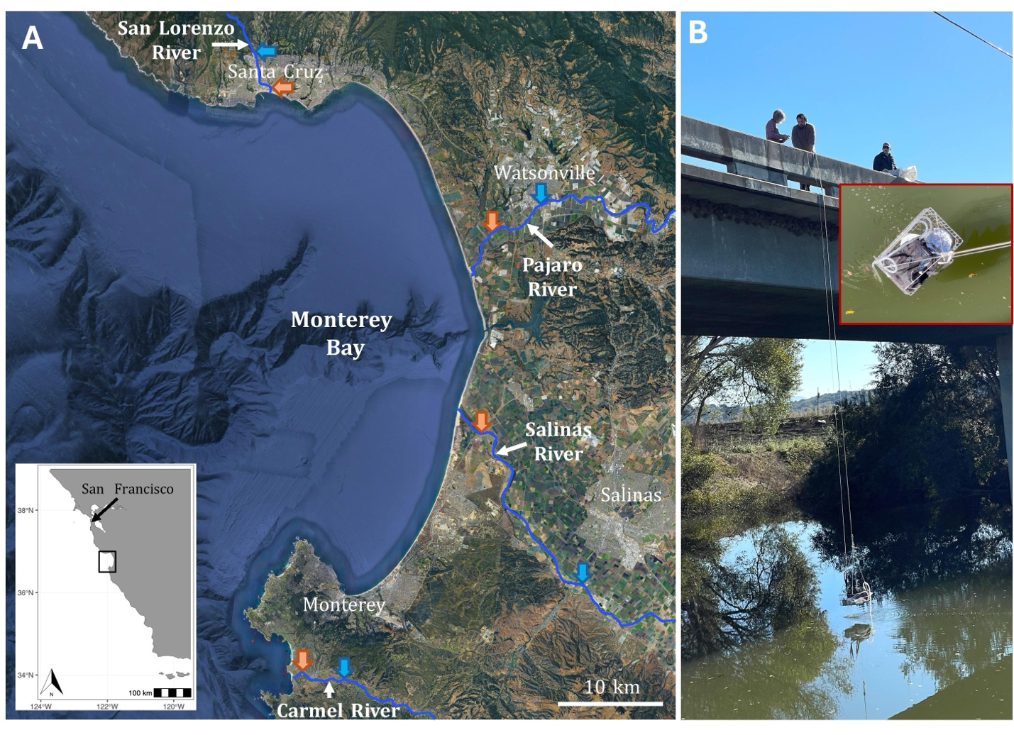
Fig. 1. Field sites and sampling. A) The four major rivers flowing into Monterey Bay – the San Lorenzo, Pajaro, Salinas, and Carmel Rivers – highlighted in blue. The blue arrows represent the location of the USGS water gauges upriver of our sampling sites. The inset map shows the sampling region outlined in black in context in central California. The orange arrows represent our sampling locations at each river. B) sampling from a bridge over the Pajaro River. Inset photo shows sampling basket including the peristaltic pump and stacked sieves.
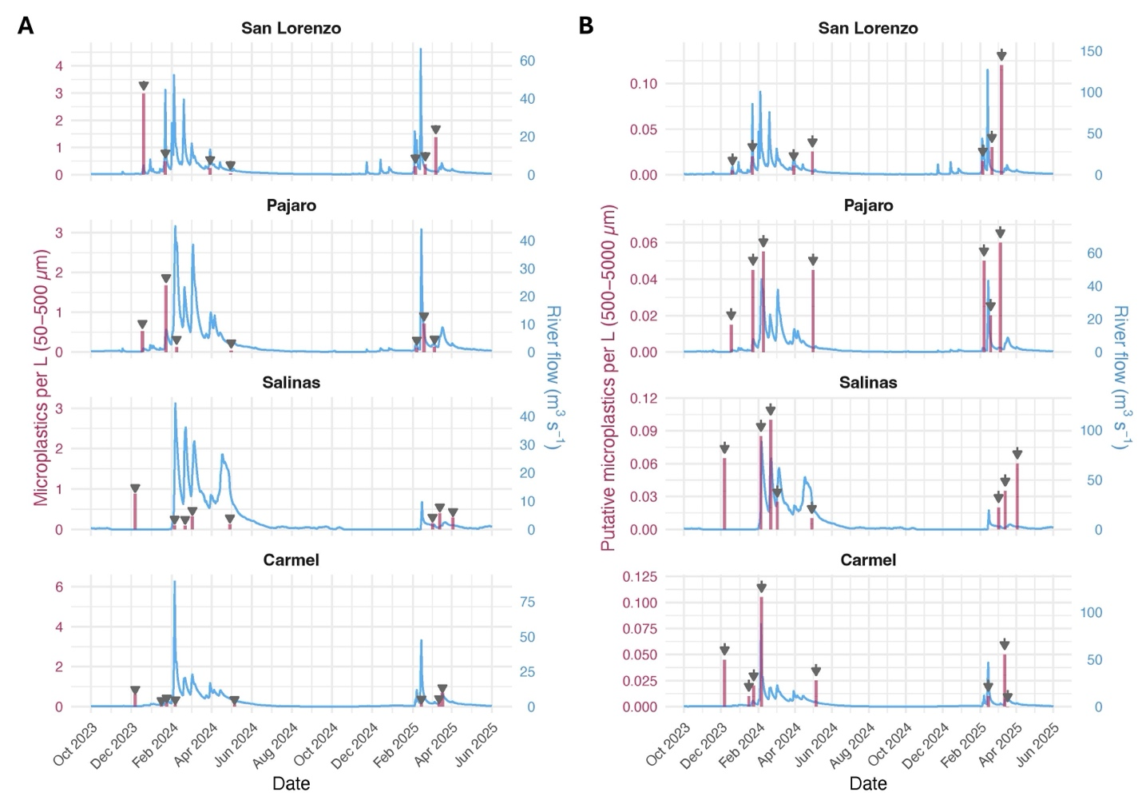
Fig. 2. Microparticle concentration and river flow. Gray vertical arrows indicate sampling events; each vertical red bar is the average value of the samples taken at the indicated date at each river. A) Concentration of small microplastics (50-500 μm) in river water overlaid with river flow data. B) Concentration of larger suspected microplastics (500-5000 μm) in river water overlaid with river flow data.
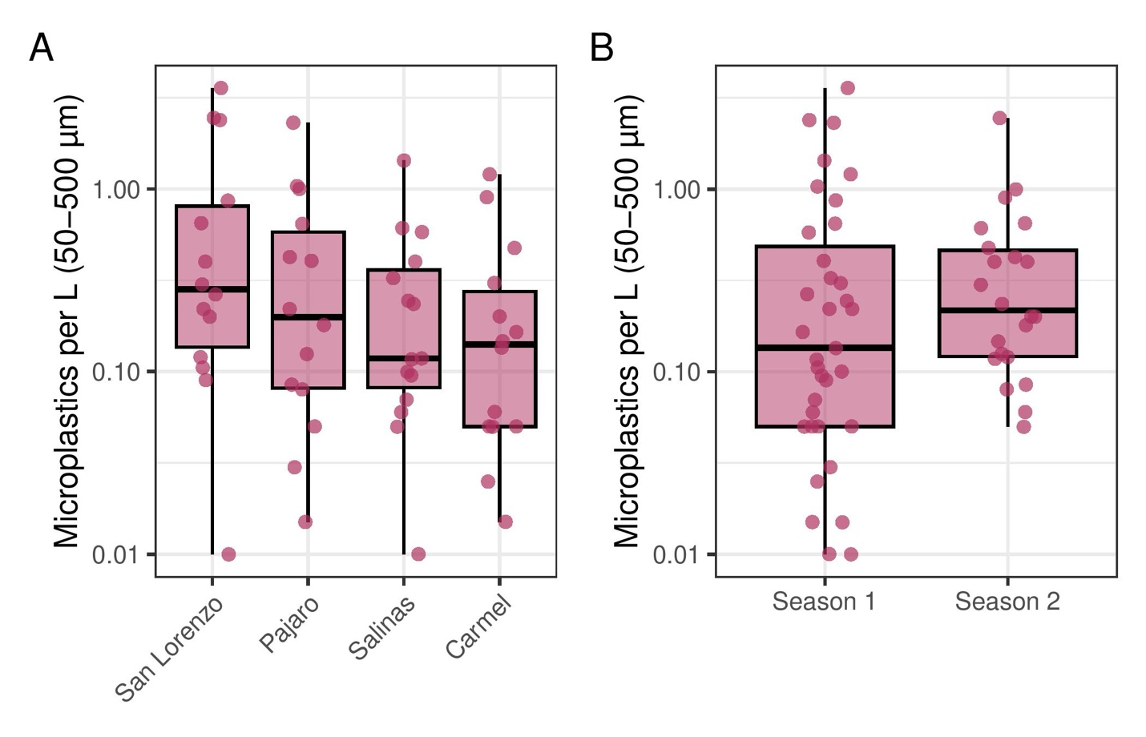Fig. 3. Concentrations of particle type by river and sampling season. Concentrations of small microplastics (50-500 μm) by A) the four river sampling sites and B) by the two sampling years.
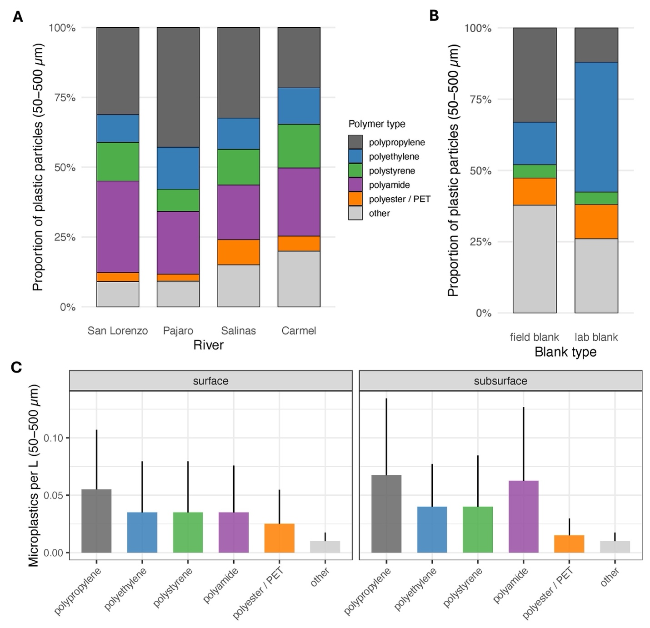
Fig. 4. Polymer types of small microplastics. A) Polymer type by river shows marginal differences. B) Polymer types by blank, which found no polyamides and higher levels of polyethylene (particularly in lab blanks) as compared to what was observed in samples of river water, shown in panel A. C) bars show the median value; error bars display median absolute deviation (MAD) of small microplastics in the samples collected at the surface and subsurface of the rivers.
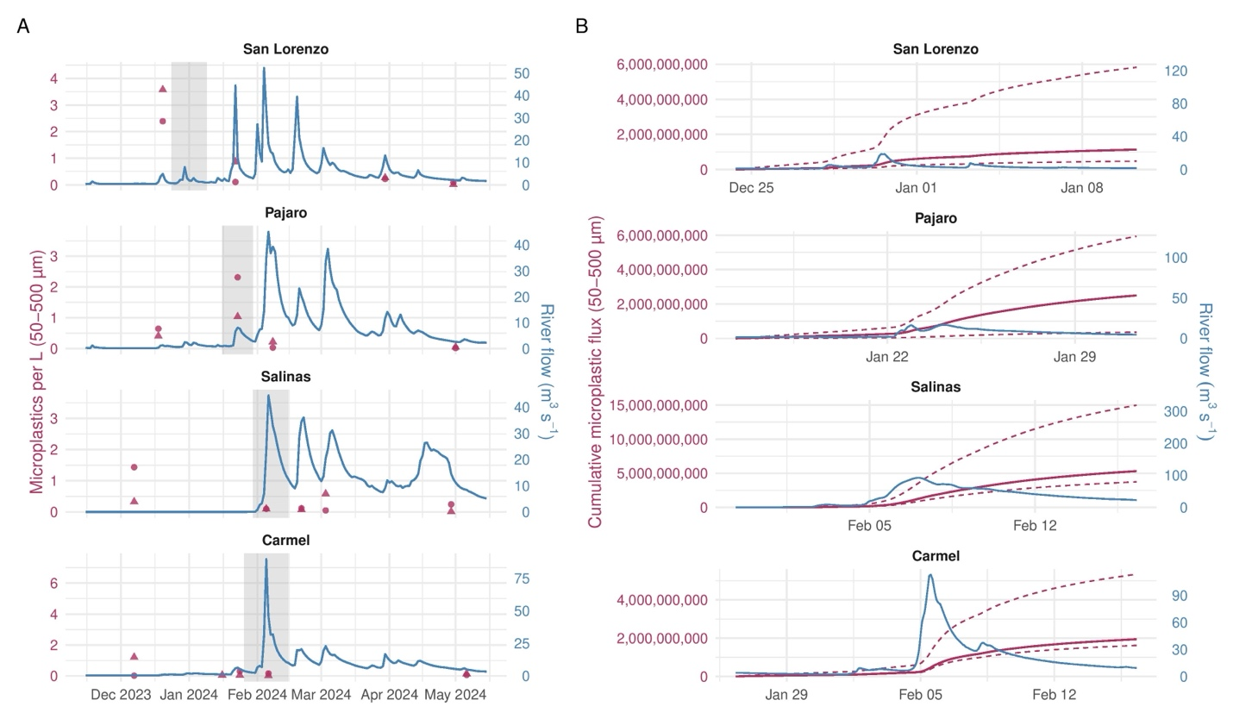
Fig. 5. Microplastic concentrations and estimated flux during the first major storm period. A) River discharge (blue) and measured microplastic concentrations (50-500 µm; maroon) during the 2023-2024 sampling season. Gray shading denotes the first major storm period used for flux estimation; points represent individual surface and subsurface samples. B) River discharge (blue) and cumulative estimated microplastic transport (maroon) during the first major storm period. Solid maroon lines represent estimates based on extrapolations of median river-specific concentrations from the 2023-2024 season; dashed lines represent estimates based on the corresponding 25th and 75th percentiles.
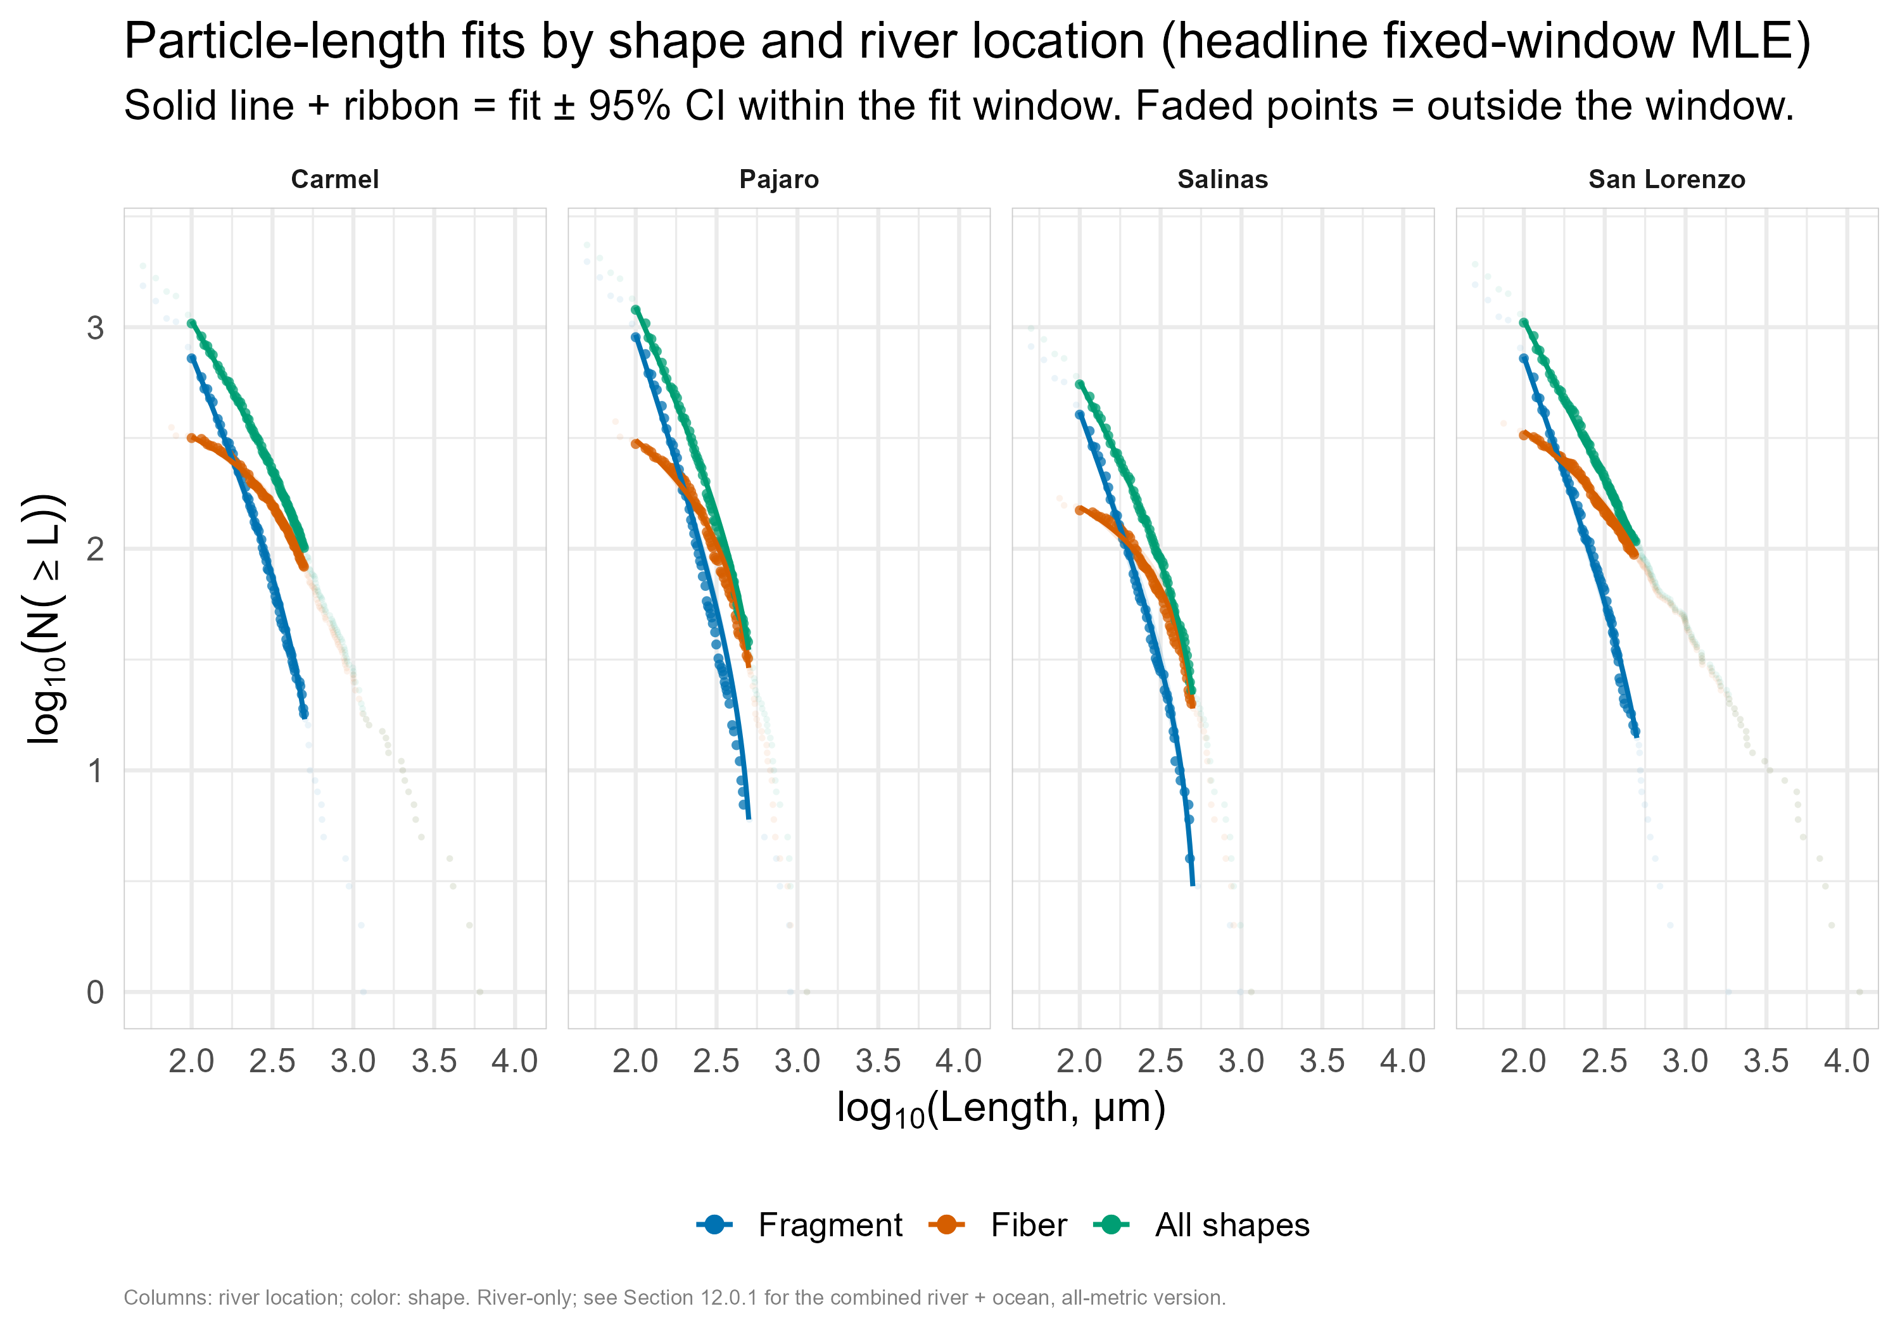
Fig. 6. Power-law particle length fits by morphology and river. Power-law fits for river water samples by morphology and river location. Points are cumulative counts; points inside the 100–500 µm fitting window are darker. Lines are power laws fitted by maximum likelihood within that window, with 95% confidence bands.
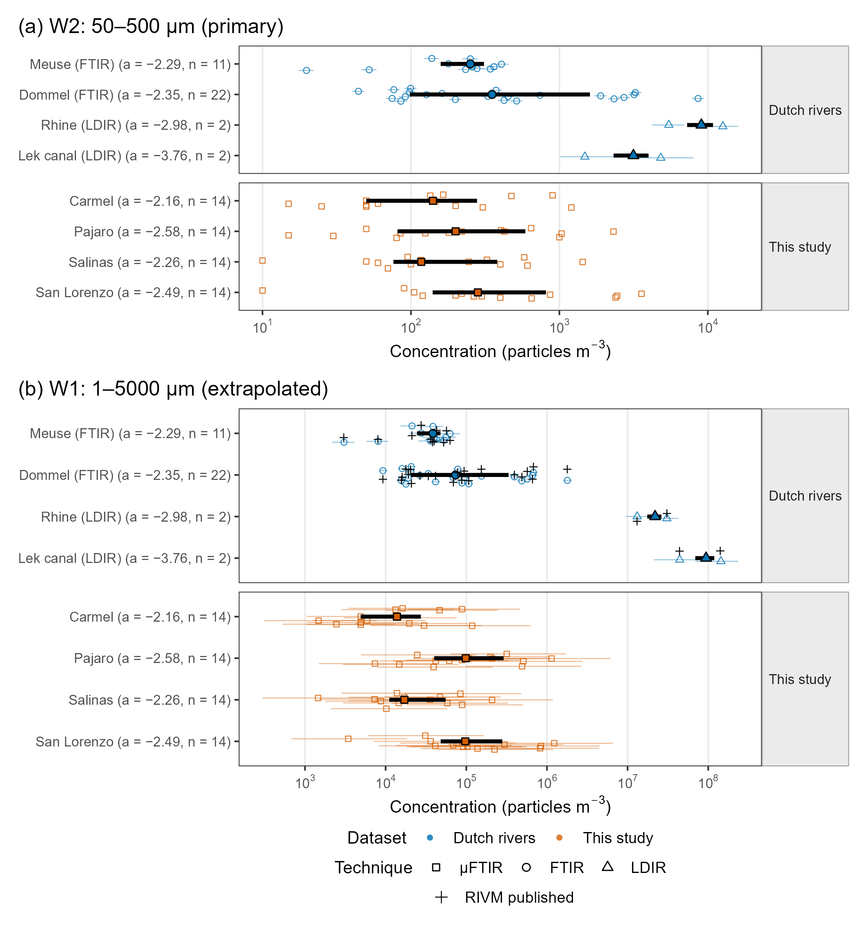
Fig. 7. Rescaled concentrations: Dutch rivers vs Monterey Bay rivers. Rescaled microplastic concentrations in Dutch rivers and the four Monterey Bay rivers, (a) rescaled to 50–500 µm (W2, primary: interior to every measured range) and (b) extrapolated to 1–5000 µm (W1). Open symbols, per-sample median; thin bars, per-sample 5–95% Monte Carlo interval; thick point ranges, median and interquartile range of the per-sample medians for each water body; symbol shape, analytical technique; colour, dataset. Row labels give the differential slope a used to rescale that row and the number of samples; this study's W2 rows are measurements, so the river-specific fitted slope is shown there for reference. Value types: Dutch W2 and W1, reconstructed here with the RIVM uncertainty method (triangular α and ±10% size limits); “+”, RIVM's own published per-sample medians (W1 only); this study W2, measured (50–500 µm sieve fraction, CF = 1); this study W1, reconstructed from each river's own single slope. Dutch FTIR slopes were fitted above xmin ≈ 170–270 µm but are applied down to 20 µm; W1 differences are dominated by slope and should be read as secondary. Dommel combines refs. 52 and 54. Slope convention: differential PSD slope a (dN/dL ∝ L^a); RIVM's positive PDF exponent α is converted as a = −α. Fitting methods differ: Dutch slopes are poweRlaw maximum-likelihood fits above an estimated xmin to particles ≤ 5000 µm, aggregated per water body and technique (ref. 51); this study's slopes are maximum-likelihood fits of a power law truncated at both ends of a fixed 100–500 µm window (the closest like-for-like estimator; the former C-PSD slopes were 0.45–0.9 steeper for three rivers). Systems differ: large perennial Dutch rivers and a canal (FTIR, refs. 52, 54; LDIR, ref. 53) versus discrete pumped samples from small, episodic Central Coast rivers (µFTIR). Dutch concentrations are study-reported totals (authors' blank and subsampling corrections), not recomputed from particles.
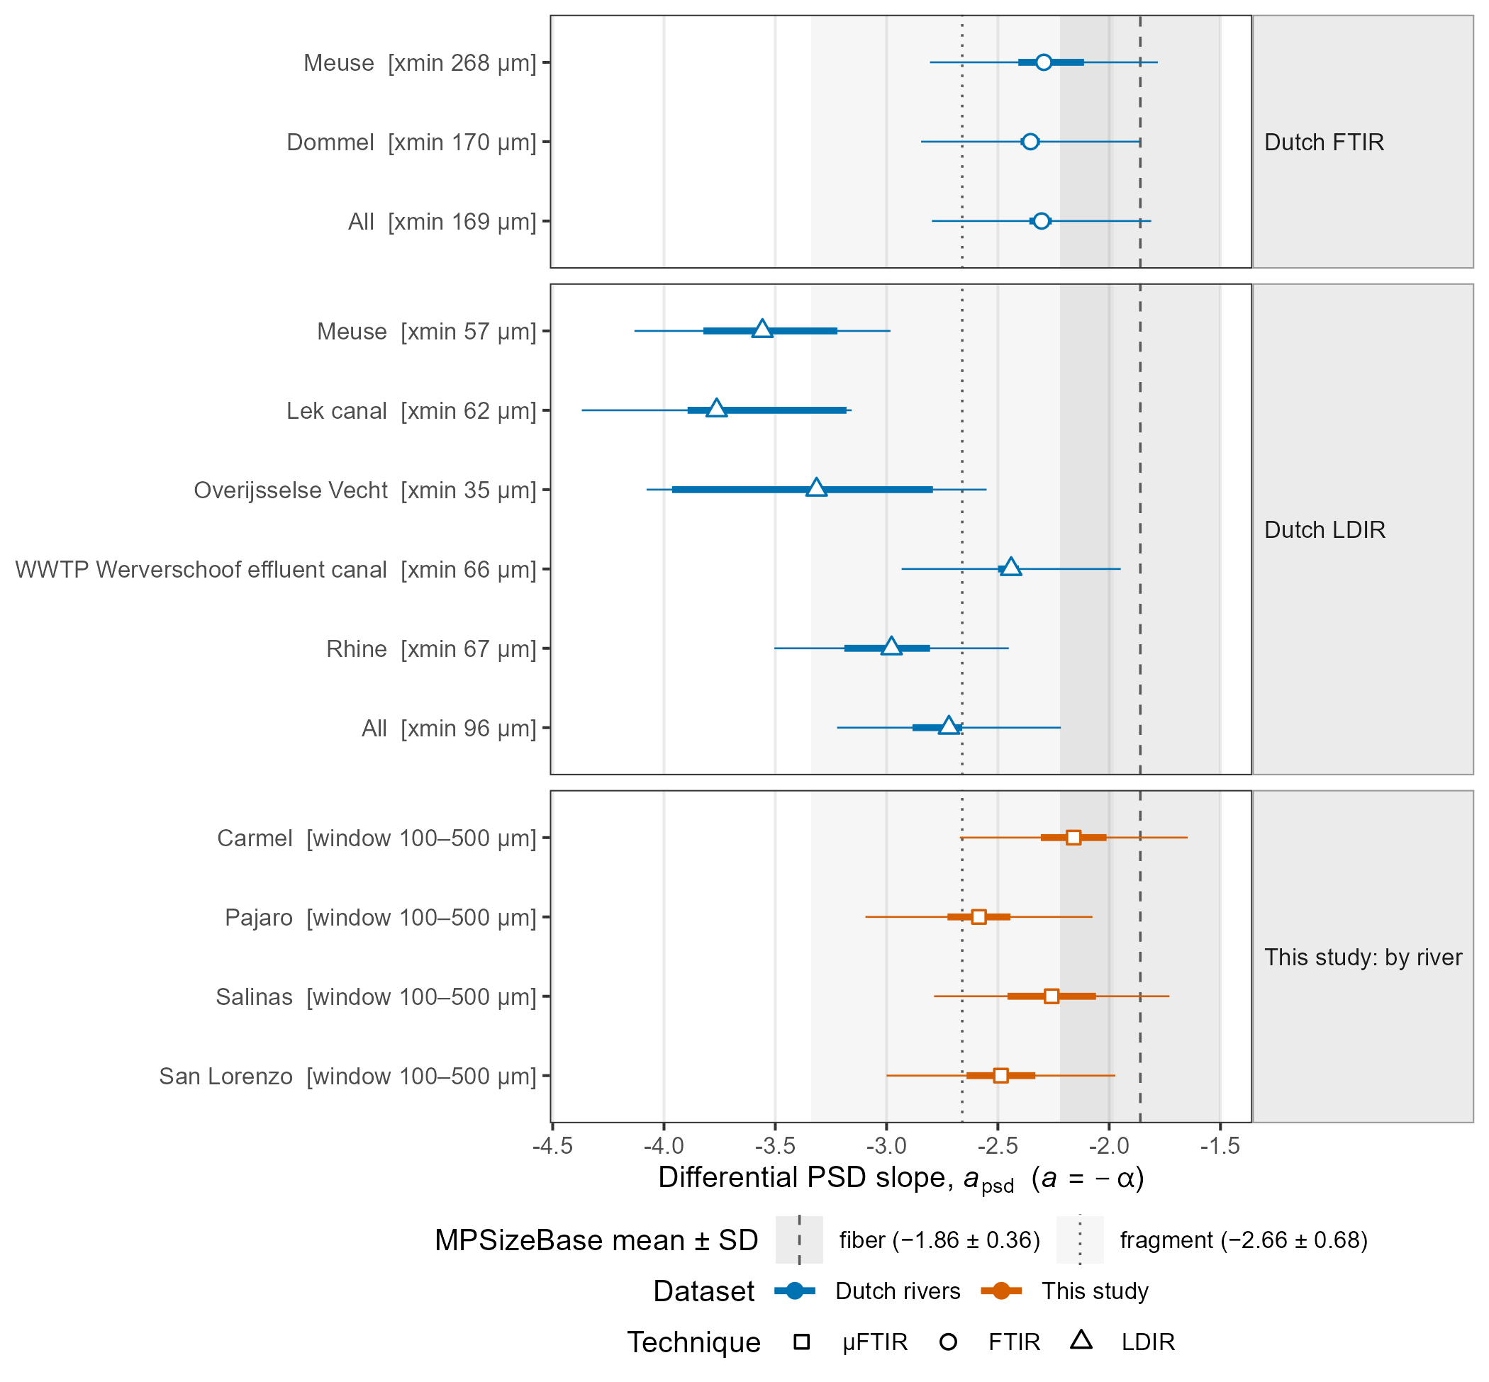
Fig. 8. Particle-size-distribution slopes: Dutch rivers vs this study. Differential particle-length PSD slopes (a) for Dutch water bodies (FTIR and LDIR; RIVM 2026-0069) and this study (by river). Points, estimate; thick bars, 95% CI (Dutch: RIVM bootstrap CI as published; this study: ±1.96 SE); thin bars, 95% interval after adding the structural slope SD (0.25) used in this study's Monte Carlo. Bracketed text gives each fit window (Dutch: estimated xmin, fit extends to 5000 µm; this study: LOD window). Shaded bands, MPSizeBase morphology means ± SD (ref. 25). Value types: Dutch, published; this study, measured. Slope convention: differential PSD slope a (dN/dL ∝ L^a); RIVM's positive PDF exponent α is converted as a = −α. Fitting methods differ: Dutch slopes are poweRlaw maximum-likelihood fits above an estimated xmin to particles ≤ 5000 µm, aggregated per water body and technique (ref. 51); this study's slopes are maximum-likelihood fits of a power law truncated at both ends of a fixed 100–500 µm window (the closest like-for-like estimator; the former C-PSD slopes were 0.45–0.9 steeper for three rivers). Systems differ: large perennial Dutch rivers and a canal (FTIR, refs. 52, 54; LDIR, ref. 53) versus discrete pumped samples from small, episodic Central Coast rivers (µFTIR). Dutch concentrations are study-reported totals (authors' blank and subsampling corrections), not recomputed from particles.
Table 1. Microplastic concentrations in each river by depth. Median with 25th-75th percentile in parentheses. Microplastic concentrations of either size class did not vary significantly between rivers or sampling depth.
River | Sample depth | MPs per L (50–500 µm) | Sample size | MPs per L (500–5000 µm) | Sample size | small:large MP ratio
San Lorenzo | surface | 0.400  (0.282–0.758) | 7 | 0.005  (0.005–0.009) | 6 | 80
San Lorenzo | subsurface | 0.200  (0.113–1.305) | 7 | 0.005  (0.005–0.018) | 7 | 40
Pajaro | surface | 0.220  (0.083–0.415) | 7 | 0.020  (0.016–0.024) | 6 | 11
Pajaro | subsurface | 0.180  (0.077–0.823) | 7 | 0.025  (0.020–0.028) | 7 | 7
Salinas | surface | 0.106  (0.068–0.344) | 8 | 0.015  (0.014–0.025) | 8 | 7
Salinas | subsurface | 0.235  (0.108–0.428) | 7 | 0.025  (0.005–0.035) | 8 | 9
Carmel | surface | 0.050  (0.050–0.305) | 7 | 0.010  (0.005–0.018) | 7 | 5
Carmel | subsurface | 0.165  (0.103–0.253) | 7 | 0.015  (0.010–0.033) | 7 | 11

References
(1) Thompson, R. C.; Courtene-Jones, W.; Boucher, J.; Pahl, S.; Raubenheimer, K.; Koelmans, A. A. Twenty Years of Microplastic Pollution Research—What Have We Learned? Science 2024, 386 (6720), eadl2746. https://doi.org/10.1126/science.adl2746.
(2) Murphy-Hagan, C.; Gray, A. B.; Singh, S.; Hapich, H.; Cowger, W.; Seeley, M. E.; Waldschläger, K. Microplastic Characterization and Transport Mode — A Flow-Integrated Approach to Sampling Urban Waterways. Environmental Research 2025, 269, 120908. https://doi.org/10.1016/j.envres.2025.120908.
(3) Lebreton, L. C. M.; Van Der Zwet, J.; Damsteeg, J. W.; Slat, B.; Andrady, A.; Reisser, J. River Plastic Emissions to the World’s Oceans. Nature Communications 2017, 8, 15611. https://doi.org/10.1038/ncomms15611.
(4) Schmidt, C.; Krauth, T.; Wagner, S. Export of Plastic Debris by Rivers into the Sea. Environ. Sci. Technol. 2017, 51 (21), 12246–12253. https://doi.org/10.1021/acs.est.7b02368.
(5) Strokal, M.; Vriend, P.; Bak, M. P.; Kroeze, C.; van Wijnen, J.; van Emmerik, T. River Export of Macro- and Microplastics to Seas by Sources Worldwide. Nat Commun 2023, 14 (1), 4842. https://doi.org/10.1038/s41467-023-40501-9.
(6) van Emmerik, T. H. M.; Frings, R. M.; Schreyers, L. J.; Hauk, R.; de Lange, S. I.; Mellink, Y. A. M. River Plastic Transport and Deposition Amplified by Extreme Flood. Nat Water 2023, 1 (6), 514–522. https://doi.org/10.1038/s44221-023-00092-7.
(7) Weiss, L.; Ludwig, W.; Heussner, S.; Canals, M.; Ghiglione, J.-F.; Estournel, C.; Constant, M.; Kerhervé, P. The Missing Ocean Plastic Sink: Gone with the Rivers. Science 2021, 373, 107–111.
(8) Meijer, L. J. J.; van Emmerik, T.; van der Ent, R.; Schmidt, C.; Lebreton, L. More than 1000 Rivers Account for 80% of Global Riverine Plastic Emissions into the Ocean. Science Advances 2021, 7 (18), eaaz5803. https://doi.org/10.1126/sciadv.aaz5803.
(9) Cowger, W.; Gray, A.; Brownlee, S.; Hapich, H.; Deshpande, A.; Waldschläger, K. Estimating Floating Macroplastic Flux in the Santa Ana River, California. Journal of Hydrology: Regional Studies 2022, 44, 101264. https://doi.org/10.1016/j.ejrh.2022.101264.
(10) van Emmerik, T.; Kieu-Le, T.-C.; Loozen, M.; van Oeveren, K.; Strady, E.; Bui, X.-T.; Egger, M.; Gasperi, J.; Lebreton, L.; Nguyen, P.-D.; Schwarz, A.; Slat, B.; Tassin, B. A Methodology to Characterize Riverine Macroplastic Emission Into the Ocean. Front. Mar. Sci. 2018, 5, 00372. https://doi.org/10.3389/fmars.2018.00372.
(11) Eppehimer, D. E.; Hamdhani, H.; Hollien, K. D.; Nemec, Z. C.; Lee, L. N.; Quanrud, D. M.; Bogan, M. T. Impacts of Baseflow and Flooding on Microplastic Pollution in an Effluent-Dependent Arid Land River in the USA. Environ Sci Pollut Res 2021, 28 (33), 45375–45389. https://doi.org/10.1007/s11356-021-13724-w.
(12) Lahon, J.; Handique, S. Impact of Flooding on Microplastic Abundance and Distribution in Freshwater Environment: A Review. Environ Sci Pollut Res 2023, 30 (56), 118175–118191. https://doi.org/10.1007/s11356-023-30819-8.
(13) Tanaka, M.; Nihei, Y. How Flooding Rivers Deliver Plastic to the Ocean: A Case Study of Microplastic and Mesoplastic Load–Discharge Relationships. Water Research 2026, 291, 125175. https://doi.org/10.1016/j.watres.2025.125175.
(14) Treilles, R.; Gasperi, J.; Tramoy, R.; Dris, R.; Gallard, A.; Partibane, C.; Tassin, B. Microplastic and Microfiber Fluxes in the Seine River: Flood Events versus Dry Periods. Science of The Total Environment 2022, 805, 150123. https://doi.org/10.1016/j.scitotenv.2021.150123.
(15) Correa-Araneda, F.; Pérez, J.; Tonin, A. M.; Esse, C.; Boyero, L.; Díaz, M. E.; Figueroa, R.; Santander-Massa, R.; Cornejo, A.; Link, O.; Jorquera, E.; Urbina, M. A. Microplastic Concentration, Distribution and Dynamics along One of the Largest Mediterranean-Climate Rivers: A Whole Watershed Approach. Environmental Research 2022, 209, 112808. https://doi.org/10.1016/j.envres.2022.112808.
(16) Kunz, A.; Schneider, F.; Anthony, N.; Lin, H.-T. Microplastics in Rivers along an Urban-Rural Gradient in an Urban Agglomeration: Correlation with Land Use, Potential Sources and Pathways. Environmental Pollution 2023, 321, 121096. https://doi.org/10.1016/j.envpol.2023.121096.
(17) Shi, H.; Yu, D.; Yin, L.; Sui, Y.; Liu, Y.; Qiao, S.; Wang, W.; Zheng, W.; Ding, D. Source-Sink Process of Microplastics in Watershed-Estuary-Offshore System. Journal of Cleaner Production 2022, 338, 130612. https://doi.org/10.1016/j.jclepro.2022.130612.
(18) Felton, A.; Farner, S.; Day, L.; Gibbs-Huerta, S. E.; Zamarripa, B.; Hutchinson, J.; Felton, A.; Farner, S.; Day, L.; Gibbs-Huerta, S. E.; Zamarripa, B.; Hutchinson, J. Spatial–Temporal Characterization of Microplastics in the Surface Water of an Urban Ephemeral River. Microplastics 2025, 4 (1). https://doi.org/10.3390/microplastics4010009.
(19) Hurley, R.; Woodward, J.; Rothwell, J. J. Microplastic Contamination of River Beds Significantly Reduced by Catchment-Wide Flooding. Nature Geoscience 2018, 11 (4), 251–257. https://doi.org/10.1038/s41561-018-0080-1.
(20) Kang, J.; Youn, O.; Lee, K.; Kyoung, Y.; Joon, W. Marine Neustonic Microplastics around the Southeastern Coast of Korea. Marine Pollution Bulletin 2015, 96, 304–312. https://doi.org/10.1016/j.marpolbul.2015.04.054.
(21) Lindeque, P. K.; Cole, M.; Coppock, R. L.; Lewis, C. N.; Miller, R. Z.; Watts, A. J. R.; Wilson-mcneal, A.; Wright, S. L.; Galloway, T. S. Are We Underestimating Microplastic Abundance in the Marine Environment? A Comparison of Microplastic Capture with Nets of Different Mesh-Size. Environmental Pollution 2020, 265, 114721. https://doi.org/10.1016/j.envpol.2020.114721.
(22) Leusch, F. Dl.; Lu, H.-C.; Perera, K.; Neale, P. A.; Ziajahromi, S. Analysis of the Literature Shows a Remarkably Consistent Relationship between Size and Abundance of Microplastics across Different Environmental Matrices. Environmental Pollution 2023, 319, 120984. https://doi.org/10.1016/j.envpol.2022.120984.
(23) Wang, S.; Mintenig, S. M.; Wu, J.; Koelmans, A. A. Implications of Method- and Instrument-Based Size Detection Limits in μFTIR-Based Microplastic Analysis. Talanta 2026, 296, 128417. https://doi.org/10.1016/j.talanta.2025.128417.
(24) Kooi, M.; Koelmans, A. A. Simplifying Microplastic via Continuous Probability Distributions for Size, Shape, and Density. Environ. Sci. Technol. Lett. 2019, 6 (9), 551–557. https://doi.org/10.1021/acs.estlett.9b00379.
(25) Segur, T.; Hough, I.; Dobiasova, N.; Voisin, D.; Richon, C.; Angot, H.; Thomas, J. L.; Sonke, J. E. Using the Power Law Size Distribution to Extrapolate and Compare Microplastic Number and Mass Concentrations in Environmental Media. Micropl.&Nanopl. 2026, 6 (1), 45. https://doi.org/10.1186/s43591-026-00205-5.
(26) Choy, C. A.; Robison, B. H.; Gagne, T. O.; Erwin, B.; Firl, E.; Halden, R. U.; Hamilton, J. A.; Katija, K.; Lisin, S. E.; Rolsky, C.; S. Van Houtan, K. The Vertical Distribution and Biological Transport of Marine Microplastics across the Epipelagic and Mesopelagic Water Column. Sci Rep 2019, 9 (1), 7843. https://doi.org/10.1038/s41598-019-44117-2.
(27) Kashiwabara, L. M.; Kahane-Rapport, S. R.; King, C.; DeVogelaere, M.; Goldbogen, J. A.; Savoca, M. S. Microplastics and Microfibers in Surface Waters of Monterey Bay National Marine Sanctuary, California. Marine Pollution Bulletin 2021, 165, 112148. https://doi.org/10.1016/j.marpolbul.2021.112148.
(28) Hamilton, B.; Rochman, C.; Hoellein, T.; Robison, B.; Van Houtan, K.; Choy, C. Prevalence of Microplastics and Anthropogenic Debris within a Deep-Sea Food Web. Marine Ecology Progress Series 2021, 675, 23–33. https://doi.org/10.3354/meps13846.
(29) Michishita, S.; Gibble, C.; Tubbs, C.; Felton, R.; Gjeltema, J.; Lang, J.; Finkelstein, M. Microplastic in Northern Anchovies (Engraulis Mordax) and Common Murres (Uria Aalge) from the Monterey Bay, California USA - Insights into Prevalence, Composition, and Estrogenic Activity. Environmental Pollution 2023, 316, 120548. https://doi.org/10.1016/j.envpol.2022.120548.
(30) Cowger, W.; Booth, A. M.; Hamilton, B. M.; Thaysen, C.; Primpke, S.; Munno, K.; Lusher, A. L.; Dehaut, A.; Vaz, V. P.; Liboiron, M.; Devriese, L. I.; Hermabessiere, L.; Rochman, C.; Athey, S. N.; Lynch, J. M.; De Frond, H.; Gray, A.; Jones, O. A. H.; Brander, S.; Steele, C.; Moore, S.; Sanchez, A.; Nel, H. Reporting Guidelines to Increase the Reproducibility and Comparability of Research on Microplastics. Applied Spectroscopy 2020, 74 (9), 1066–1077. https://doi.org/10.1177/0003702820930292.
(31) Cowger, W.; Markley, L. A. T.; Moore, S.; Gray, A. B.; Upadhyay, K.; Koelmans, A. A. How Many Microplastics Do You Need to (Sub)Sample? Ecotoxicology and Environmental Safety 2024, 275, 116243. https://doi.org/10.1016/j.ecoenv.2024.116243.
(32) Cole, M. A Novel Method for Preparing Microplastic Fibers. Sci Rep 2016, 6 (1), 34519. https://doi.org/10.1038/srep34519.
(33) Hidalgo-Ruz, V.; Gutow, L.; Thompson, R. C.; Thiel, M. Microplastics in the Marine Environment: A Review of the Methods Used for Identification and Quantification. Environ. Sci. Technol. 2012, 46 (6), 3060–3075. https://doi.org/10.1021/es2031505.
(34) Kooi, M.; Primpke, S.; Mintenig, S. M.; Lorenz, C.; Gerdts, G.; Koelmans, A. A. Characterizing the Multidimensionality of Microplastics across Environmental Compartments. Water Research 2021, 202 (July). https://doi.org/10.1016/j.watres.2021.117429.
(35) DeCicco, L.; Hirsch, R.; Lorenz, D.; Read, J.; Walker, J.; Platt, L.; Watkins, D.; Blodgett, D.; Johnson, M.; Krall, A.; Stanish, L.; Zemmels, J.; Hinman, E.; Mahoney, M. dataRetrieval: Retrieval Functions for USGS and EPA Hydrology and Water Quality Data, 2025. https://cran.r-project.org/web/packages/dataRetrieval/index.html (accessed 2025-12-13).
(36) Hoffman, M. J.; DiBenedetto, M. H. How Size-Dependent Settling Can Both Bias and Inform Microplastics Observations. Environ. Res. Commun. 2026, 8 (6), 065061. https://doi.org/10.1088/2515-7620/ae76df.
(37) Cowger, W.; Karapetrova, A.; Lincoln, C.; Chamas, A.; Sherrod, H.; Leong, N.; Lasdin, K. S.; Knauss, C.; Teofilović, V.; Arienzo, M. M.; Steinmetz, Z.; Primpke, S.; Darjany, L.; Murphy-Hagan, C.; Moore, S.; Moore, C.; Lattin, G.; Gray, A.; Kozloski, R.; Bryksa, J.; Maurer, B. Open Specy 1.0: Automated (Hyper)Spectroscopy for Microplastics. Anal. Chem. 2025, 97 (32), 17345–17356. https://doi.org/10.1021/acs.analchem.5c00962.
(38) Benjamini, Y.; Hochberg, Y. Controlling the False Discovery Rate: A Practical and Powerful Approach to Multiple Testing. Royal Statistical Society. Journal. Series B: Methodological 1995, 57 (1), 289–300. https://doi.org/10.1111/j.2517-6161.1995.tb02031.x.
(39) Wickham, H.; Averick, M.; Bryan, J.; Chang, W.; McGowan, L. D.; François, R.; Grolemund, G.; Hayes, A.; Henry, L.; Hester, J.; Kuhn, M.; Pedersen, T. L.; Miller, E.; Bache, S. M.; Müller, K.; Ooms, J.; Robinson, D.; Seidel, D. P.; Spinu, V.; Takahashi, K.; Vaughan, D.; Wilke, C.; Woo, K.; Yutani, H. Welcome to the Tidyverse. Journal of Open Source Software 2019, 4 (43), 1686. https://doi.org/10.21105/joss.01686.
(40) Oksanen, J.; Simpson, G. L.; Blanchet, F. G.; Kindt, R.; Legendre, P.; Minchin, P. R.; O’Hara, R. B.; Solymos, P.; Stevens, M. H. H.; Szoecs, E.; Wagner, H.; Barbour, M.; Bedward, M.; Bolker, B.; Borcard, D.; Borman, T.; Carvalho, G.; Chirico, M.; De Caceres, M.; Durand, S.; Evangelista, H. B. A.; FitzJohn, R.; Friendly, M.; Furneaux, B.; Hannigan, G.; Hill, M. O.; Lahti, L.; Martino, C.; McGlinn, D.; Ouellette, M.-H.; Ribeiro Cunha, E.; Smith, T.; Stier, A.; Ter Braak, C. J. F.; Weedon, J. Vegan: Community Ecology Package, 2001, 2.7-1. https://doi.org/10.32614/CRAN.package.vegan.
(41) Fox, J.; Weisberg, S.; Price, B.; Adler, D.; Bates, D.; Baud-Bovy, G.; Bolker, B.; Ellison, S.; Firth, D.; Friendly, M.; Gorjanc, G.; Graves, S.; Heiberger, R.; Krivitsky, P.; Laboissiere, R.; Maechler, M.; Monette, G.; Murdoch, D.; Nilsson, H.; Ogle, D.; Proctor, I.; Ripley, B.; Short, T.; Venables, W.; Walker, S.; Winsemius, D.; Zeileis, A.; R-Core. Car: Companion to Applied Regression, 2026. https://cran.r-project.org/web/packages/car/index.html (accessed 2026-09-06).
(42) Geyer, R.; Jambeck, J. R.; Law, K. L. Production, Use, and Fate of All Plastics Ever Made. Science Advances 2017, 3 (7), e1700782. https://doi.org/10.1126/sciadv.1700782.
(43) Xia, F.; Wang, Y.; Wang, D.; Cai, Y.; Zhang, J. Seasonal Pulse Effect of Microplastics in the River Catchment-From Tributary Catchment to Mainstream. Journal of Environmental Management 2023, 342, 118316. https://doi.org/10.1016/j.jenvman.2023.118316.
(44) Ross, M. S.; Loutan, A.; Groeneveld, T.; Molenaar, D.; Kroetch, K.; Bujaczek, T.; Kolter, S.; Moon, S.; Huynh, A.; Khayam, R.; Franczak, B. C.; Camm, E.; Arnold, V. I.; Ruecker, N. J. Estimated Discharge of Microplastics via Urban Stormwater during Individual Rain Events. Front. Environ. Sci. 2023, 11. https://doi.org/10.3389/fenvs.2023.1090267.
(45) Werbowski, L. M.; Gilbreath, A. N.; Munno, K.; Zhu, X.; Grbic, J.; Wu, T.; Sutton, R.; Sedlak, M. D.; Deshpande, A. D.; Rochman, C. M. Urban Stormwater Runoff: A Major Pathway for Anthropogenic Particles, Black Rubbery Fragments, and Other Types of Microplastics to Urban Receiving Waters. ACS EST Water 2021, 1 (6), 1420–1428. https://doi.org/10.1021/acsestwater.1c00017.
(46) Carr, S. A.; Liu, J.; Tesoro, A. G. Transport and Fate of Microplastic Particles in Wastewater Treatment Plants. Water Research 2016, 91, 174–182. https://doi.org/10.1016/j.watres.2016.01.002.
(47) Mason, S. A.; Garneau, D.; Sutton, R.; Chu, Y.; Ehmann, K.; Barnes, J.; Fink, P.; Papazissimos, D.; Rogers, D. L. Microplastic Pollution Is Widely Detected in US Municipal Wastewater Treatment Plant Effluent. Environmental Pollution 2016, 218, 1045–1054. https://doi.org/10.1016/j.envpol.2016.08.056.
(48) Mintenig, S. M.; Int-Veen, I.; Löder, M. G. J.; Primpke, S.; Gerdts, G. Identification of Microplastic in Effluents of Waste Water Treatment Plants Using Focal Plane Array-Based Micro-Fourier-Transform Infrared Imaging. Water Research 2017, 108, 365–372. https://doi.org/10.1016/j.watres.2016.11.015.
(49) Botterell, Z. L. R.; Beaumont, N.; Dorrington, T.; Steinke, M.; Thompson, R. C.; Lindeque, P. K. Bioavailability and Effects of Microplastics on Marine Zooplankton: A Review. Environmental Pollution 2019, 245 (2019), 98–110. https://doi.org/10.1016/j.envpol.2018.10.065.
(50) Savoca, M. S.; Murphy, E. L.; Brandon, A. M.; Thornton Hampton, L. M.; Roman, L.; Kong, M.; Fernandes, M. E.; Abrokwah, S.; Darter, C.; Galgani, F.; Provencher, J. F.; Alimba, C.; Santos, R. G.; Hardesty, B. D. The Effects of Plastic Pollution on Biodiversity. Nat. Rev. Biodivers. 2026, 2 (7), 425–440. https://doi.org/10.1038/s44358-026-00170-0.

(51) Quik, J. T. K.; van Breemen, P.; Hids, A. R.; van Loon, S.; Mintenig, S. M.; Koelmans, A. A. Screening Level Ecological Risk Assessment of Microplastics in Dutch Surface Waters; RIVM Letter Report 2026-0069; National Institute for Public Health and the Environment (RIVM): Bilthoven, 2026. https://doi.org/10.21945/RIVM-2026-0069. Data and code: https://github.com/rivm-syso/MicroplasticsERA_water.
(52) Mintenig, S. M.; Kooi, M.; Erich, M. W.; Primpke, S.; Redondo-Hasselerharm, P. E.; Dekker, S. C.; Koelmans, A. A.; van Wezel, A. P. A Systems Approach to Understand Microplastic Occurrence and Variability in Dutch Riverine Surface Waters. Water Research 2020, 176, 115723. https://doi.org/10.1016/j.watres.2020.115723.
(53) Mughini-Gras, L.; van der Plaats, R. Q. J.; van der Wielen, P. W. J. J.; Bauerlein, P. S.; de Roda Husman, A. M. Riverine Microplastic and Microbial Community Compositions: A Field Study in the Netherlands. Water Research 2021, 192, 116852. https://doi.org/10.1016/j.watres.2021.116852.
(54) Mintenig, S. M.; Hunnestad, A.; Koelmans, A. A. Microplastics in het oppervlaktewater van de Dommel; Wageningen University & Research, 2025.
(55) Aban, I. B.; Meerschaert, M. M.; Panorska, A. K. Parameter Estimation for the Truncated Pareto Distribution. Journal of the American Statistical Association 2006, 101 (473), 270–277. https://doi.org/10.1198/016214505000000411.
(56) Deluca, A.; Corral, Á. Fitting and Goodness-of-Fit Test of Non-Truncated and Truncated Power-Law Distributions. Acta Geophysica 2013, 61 (6), 1351–1394. https://doi.org/10.2478/s11600-013-0154-9.
(57) Clauset, A.; Shalizi, C. R.; Newman, M. E. J. Power-Law Distributions in Empirical Data. SIAM Review 2009, 51 (4), 661–703. https://doi.org/10.1137/070710111.
(58) Edwards, A. M.; Robinson, J. P. W.; Plank, M. J.; Baum, J. K.; Blanchard, J. L. Testing and Recommending Methods for Fitting Size Spectra to Data. Methods in Ecology and Evolution 2017, 8 (1), 57–67. https://doi.org/10.1111/2041-210X.12641.

Acknowledgements
We are deeply indebted to the volunteers that helped with both the labwork and fieldwork for this project.

Conflict of Interest Statement
The authors declare no conflict of interest

Code Availability
All data and code used in this study are available at https://github.com/mssavoca/W2W_river_plastics. The Dutch-river benchmark analysis (R/rivm_utils.R and R/rivm_benchmark.qmd) and its derived data tables (data_output/rivm_benchmark_*_v1.csv; data_input/external/rivm/derived/) are included. Raw Dutch data and code are available from the RIVM repository (https://github.com/rivm-syso/MicroplasticsERA_water; EUPL-1.2) and are not redistributed here; some underlying particle data (Bäuerlein et al.) are not publicly available.

